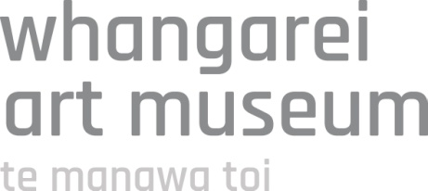

White Cube Black Box Project
Exhibition proposal | Application form

Applications close 4.30pm 30 May 2016

Contact details

Mr/Mrs/Ms/Miss/Dr
Name:
Phone number:
Email:
Postal address:

Exhibition details

Exhibition title:

Brief description of the exhibition main themes and ideas (continue on separate page where necessary; please attach design drawings / images where applicable):

Brief description of artists involved (continue on separate page where necessary):

Art works

Number of art works:
Estimated running metres / floor space required: m / m³

Please tick all that apply, please attach images where applicable

Works on canvas/board
Works on paper
Photography
Mixed media
Sculpture
Design
Decorative arts
Maori art/taonga
Moving image / digital art
Sound art
Performance art / installation
Other (please specify)

Other objects / items

Number of objects:

Please tick all that apply

Ephemera
Hands on/interactive objects
Custom exhibition furniture (eg.
plinths)
Books
Digital media
Other (please specify)

Art works requiring extra support

Please specify if any of the art works are extra large, heavy, needs assembly or have particular requirements on space, installation, interpretation, equipment and care (continue on separate page where necessary):

Budget

Please attach a project budget indicating any associated costs. This could include items such as travel and freight, framing, equipment hire etc.

Timeline

Please provide a timeline with key dates outlined for your exhibition development process (please continue on separate sheet where necessary):

Date | Task / process

Thank you for your application – please submit using the following methods before 4.30pm on Monday 30 May 2016.

Email to: whangareiartmuseum@wdc.govt.nz

Post to:
Whangarei Art Museum
PO Box 1024
Whangarei 0140
Hand deliver to:
Whangarei Art Museum
The Hub, 91 Dent Street
Town Basin

For enquiries please contact:
Whangarei Art Museum
(09) 430 4240
whangareiartmuseum@wdc.govt.nz

